Auto-focus&Zoom PC board
Technical specifications
Product Series | Continuous zoom lens circuit panel
Product Description | 1. focusing double motor control, support photoelectric one-click focusing, focusing function customization;
 | 2.5 V/12V Motor optional;
 | 3. position servo, single-end zoom or focus adjustment, clear imaging point calibration and other functions;
Name |  | FO-H617-D05/FO-H617-D12
Main functions | Set the variable position | Set the variable position independently
 | Set the focusing position | Set the focusing position independently
 | Double focus with one key | At the same time set up the zoom
 | Two-way manual focusing | Select the focusing direction to manually stop
 | Double manual | Select Change Direction Manual Stop
 | Speed gear setting | Change the zoom 4 gear setting
 | One key focus | Set to Best Clear Point
 | Focus | The process is clear
Auxiliary functions | Border self-inspection | Automatic inspection of physical boundaries
 | One-click diagnosis | Check potentiometer connection failure
 | Clear Point Calibration Table | -40℃~60℃ Eight Temperature Section Clear Point Calibration Table
External Temperature Transmission Board | Scope of work | -40℃~60℃
 | Precision | ±2℃
Communications | Mode of communication | R S232/RS 422
 | Type of communication | baud rate :57600(N,8,1)
Upgrade | Firmware upgrade | Manufacturer J TAG upgrade
Hardware features | Power supply | Power supply reverse does not damage hardware
 | One key focus | Focus time ≤5 seconds
 | Focus | Fuzzy state and clear state can follow the focus
 | Average position control accuracy | Average position control accuracy ≤6
 | Clear Point Calibration Table | Single table clear points up to 24 data
 | High precision position reference source | 0.2% Reference Power Supply
Motor | DC motor | 5V/12V motor optional
Interface | External integrated interface | FWF12504-S12B24W5M
 | Integrated Motor Interface | FWF12504-S10B24W5M
 | Temperature Transmission Interface | FWF12504-S 04B24W5M
 | Debugging interface | FWF12506-S06S24W5B
 | Power supply | DC12V
 | Power consumption | 0.4 W@12v、25℃
Mechanical | Weight | g ≤10
 | Dimensions | 45 mmx38mm
Environmental standards | Working temperature | -40℃～+60℃
 | Working humidity | ~90% RH 0
 | Storage temperature | -40℃～+60℃
 | Storage humidity | ~90% RH 0
Packaging content | Standard packing list | Servo X1 Board
 |  | Inner liner
 |  | Quality Assurance Card
 |  | QA test report
 |  | Corrugated box (lined with foam)
 |  | desiccant

II. External description of the interface

2.1 External integrated interface
Connector Type: FWF12504-S12B24W5M (12PIN/1.25mm spacing/slope)
External debugging interface (12 pins)
Pin number | Signal name | Signal definition
J2.1、J2.2 | 12V_IN | External Power Supply
J2.2、J2.3 | PGND | External Power Supply
J2.5 | RS422_A | 422 serial A
J2.6 | RS422_B | 422 serial B
J2.7 | RS422_Z | 422 serial Z
J2.8 | RS422_Y | 422 serial Y
J 2.9 | GND | Digital
J 2.10 | RS232_TX | 232 Serial Transmission (Local)
J2.11 | RS232_RX | 232 Serial Receiving (Local)
J2.12 | GND | Digital

2.2 Integrated Motor Interface
Connector Type: FWF12504-S10B24W5M (10PIN/1.25mm spacing/slope)
External lens interface (10 stitches)
Pin number | Signal name | Signal definition
J1.1 | OUT_FOCUS- | Motor focusing output
J1.2 | OUT_FOCUS+ | Motor focusing output
J1.3 | OUT_ZOOM- | Motor Variable Output
J1.4 | OUT_ZOOM+ | Motor Variable Output
J1.5 | VREF | potentiometer baseline
J1.6 | GND | Digital
J1.7 | ADC1 | ADC feedback
J1.8 | VREF | potentiometer baseline
J1.9 | GND | Digital
J1.10 | ADC2 | ADC feedback

2.3 Temperature interface
Connector Type: FWF12504-S 04B24W5M (4PIN/1.25mm spacing/slope)
Temperature transfer interface (4 pins)
Pin number | Signal name | Signal definition
J5.1 | MCU_3V3 | 3.3 V Power
J5.2 | MCU_I2C1_SCL | SCL
J5.3 | MCU_I2C1_SDA | SDA
J5.4 | GND | Digital

2.4 Debugging interface
Manufacturer reserve.

.5 2. Overall external interface diagram
The overall external interface diagram of the hardware is shown in figure 1:
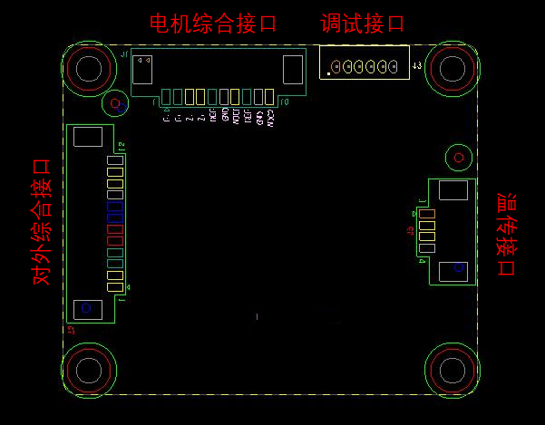
Figure 1. The overall external interface diagram of the hardware

